Team ASICname

Matthew Cabrera, Kenneth Cula, Kassandra Jordan, Duncan McDonald, Yunus Mohammed

### Goal of the project

The goal of this project is to analyze the performance of RIPE Atlas probes connected to Starlink user terminals across the world. In this analysis, we also set out to identify possible reasons why certain trends do (or do not) appear.

### Methodology

#### 1.1 Probe Identification and Selection

We first explored how to get the current, active probes through the [REST endpoints that RIPE Atlas exposes](https://atlas.ripe.net/docs/apis/rest-api-reference/). We then found that the Starlink probes shared the ASN 14593.

From the list of current, active probes under the Starlink ASN (54 probes as of 05/01/23), we picked 14 probes to monitor, each identified by a unique probe ID. To get a better understanding of how the probes performed worldwide, we selected a sample of probes from across the globe:

**North America (4):** 61537 (USA East Coast), 60929 (USA West Coast), 61113 (USA  
 Alaska), 60510 (Canada)

**Australia (3):** 52955 (New Zealand), 52918 (Australia West Coast), 1004453 (Australia  
 East Coast)

**Caribbean (1):** 1005627 (Haiti)

**South America (1):** 26834 (Chile)

**Europe (5):** 1004876 (Italy), 1002750 (Germany), 35681 (Austria), 17979 (UK), 20544  
 (Poland)

We then pinged *bing.com* from the selected probed in 15-minute intervals. Each of these pings sent 3 packets from the probe to *bing.com* and allowed us to receive latency statistics. The most valuable statistic that we received was the round-trip time (RTT) of each packet. This pinging and data collection was performed over the course of 24 hours twice, once during the weekend and once during the weekend. The data collection is done by RIPE Atlas and is given some measurement ID that can be used to request a JSON from their REST API.

#### 1.2 Data parsing and plotting

With the JSONs provided in the HTTP request of the measurement results, we programmed a script to parse through and extract the recorded RTT data (with pre-calculated averages, mins, and maxes).

We used Dash to display multiple *plotly* graphs, where each graph is one of the above pre-calculated data metrics. We then set each probe to be their own trace, which allowed us to analyze the data more effectively by isolating or comparing certain probes on the graph. Each of these probe traces has some hover text that provides more context and a link that corresponds to their RIPE Atlas page. We configure it such that the X axis is time in Coordinated Universal Time (UTC) and Y axis is latency (RTT) in ms.

#### 1.3 Analysis and hypothesizes

From our data, we see major spikes in latency from certain probes. Namely, Alaska and Western Australia experience high latency. Generally, the other probes remained in a stable range of 0 to 100 ms. We did some research on a few possible causes of this spike.

Firstly, our research shows that there are 4 ground stations in Alaska and 4 in Western Australia. The density of ground stations per unit area is lower in Alaska and Western Australia than it is in the general areas of the other probes. This could be one explanation for the unusually high latency, since the ground stations may not be equipped to handle high traffic. In particular this is the case because of the way the routing for many of the starlink satellites work. When the probe sends a request to a page on the internet, the user terminal it is connected to on the ground sends a signal up onto the starlink network and is intercepted by the closest satellite. If this satellite is a Starlink v1 satellite, then it will immediately proceed to re-downlink the signal to the closest ground station. This means that for v1 satellites, it is important for there to be a decent density of ground stations around the location of the probe, so when a v1 satellite redirects the signal back down, it has stations ready to pick up the signal.

Another possible explanation we found in our research could be the lack of satellites above those regions. If there is not a high density of satellites above the probe’s user terminal, there will not be as much bandwidth for communication, since there are less satellites to intercept the signal. This effect is irregardless of what versions of the satellite are above the probe. This is especially true for Alaska which is close enough to the polar region that there is a very low concentration of satellites above it at any given time, meaning that for Alaska, this is likely the more strongly contributing factor to the increased latency. However, in Western Australia, there is a pretty high density of satellites over the probe at any given time, so it is likely that Australia is being more affected by the lack of ground station density.

In order to overcome these regional spikes in latency, SpaceX has a few options. One of which it seems they are already beginning to implement. With the creation of later versions of starlink, like the v2 satellites, the signal is instead sent between satellites using laser communications before downlinking to a ground station. This allows for the network to optimize at which position to send the signal before downlinking to a ground station. If there is a lack of available ground stations around the user terminal, the v2 starlinks will send the signal closer towards the destination before downlinking. As more v2 satellites are put into orbit, the problems with ground station density will begin to disappear. This is important to implement because currently in areas such as Africa and Asia there are little to no ground stations available, meaning until robust laser communication is implemented with v2 satellites, these areas won’t be able to reliably join the starlink network. In fact, this is why these regions had no probes available on the Ripe Atlas site.

The option that would improve areas such as Alaska, would be to send more satellites into orbit near the poles. This is less of an ideal solution, however, since getting satellites into orbit around the poles due to launches being closer to the equator. Even if spacex expended the additional resources to fill the poles with satellites, they will not last as long due to the increased stress from the magnetic field at the poles. Finally, most of the regions on the poles typically have a lower population meaning there is far less demand for starlink anyways, so places such as alaska that have a higher population are an unfortunate byproduct of this situation.

Going forward, it seems that SpaceX definitely has the potential and capability to not only bring the internet to the entire globe, but to also serve as a possible replacement for cable, since once the regional latency spikes are fixed, the sub-100ms RTTs of starlink would be comparable to what is seen with cable already.

### 

### Results

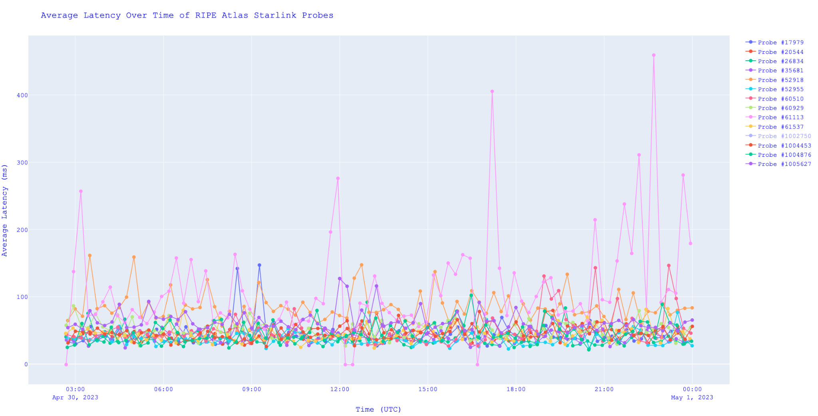

Above is the graph with the measurements of the average latency for each probe taken every 15 minutes during a continuous 24 hour period. On the Y axis is the average latency of these measurement packets in milliseconds. The X axis is time in Universal Coordinated Time. The majority of probes operate with latency between 0-100 ms but for some probes the average latency is much more erratic. Particularly, the pink measurements are the Alaska region probe and the orange measurements are western Australian region probe

.

Above is a visual representation of the probes analyzed with cooler colors representing low latency and warmer colors representing high latency. As can be seen most probes remain in blue or green, but the Alaska and western Australia probes turn very warm during spikes of latency.

### Extra Credit

If we had more probes but a limited measurement budget, there are several ways we could choose a subset of probes. The method we chose for this project was to get a wide variety of regions in many different continents to see latency differences between regions. This metric would help eliminate probes that give relatively redundant information such as probes all bunched together in the same metropolitan areas. This decision was very insightful and we think it is one of the most helpful criteria to see how global the Starlink network is trying to be. Moreover, another metric we think would be important to analyze would be a selection of probes that vary in urbanization. Namely, we would choose probes in Urban, suburban, and rural regions of a continent to see how cities and metropolitan areas impact latency. This criteria would also eliminate many redundant probes that would have nearly the same latency as other probes in close proximity.

### 

### 

### 

### References

<https://atlas.ripe.net/docs/tools-and-code/sagan.html>

<https://atlas.ripe.net/docs/apis/rest-api-reference/>

<https://starlinkinsider.com/starlink-gateway-locations/>

<https://satellitemap.space>